HUMANKIND. BE BOTH.
Fresno Unified School District – Student Advisory Board

National School Boards Association 2015 Convention Session
How can you inspire your students to start their own positive impact program?

How we got to the Human Element Campaign:
- The words ‘anti-bullying’ were not creating the change we wanted to see. We need to tell people what to do, instead of what not to do.
- Tired of hearing the slurs, hateful words, and observing hurtful actions.
- We wanted to make change – and we wanted our message to be positive and teach others.
- Kindness is a culture and we must show what that looks like on a daily basis.
- Vision: To protect and support each other through kindness as a culture
Watch our first slide show here:
https://www.youtube.com/watch?v=0-aW_l6dKLo
Watch our presentation to the Fresno Unified School Board here: https://www.youtube.com/watch?v=cFqk25kfgQs
Bracelets
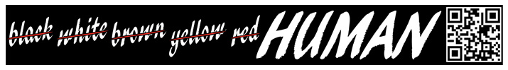
Program First Steps:
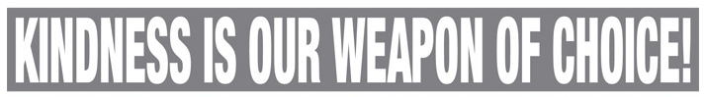
- Passionate Students
- Relevant topic…and made it POSITIVE
- Total creative control given to the students
- Adult Guidance, but no Hijacking!
- Created Partnerships with local business leaders and District leadership
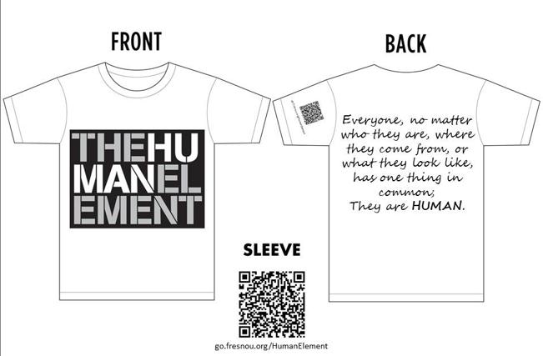
- Complete support from School Board
T-Shirts

Watch our first videos here:
https://www.youtube.com/watch?v=IBxQokFIcEA
https://www.youtube.com/watch?v=Fy2OIMJMlH4
https://www.youtube.com/watch?v=HD-_2iXEXak

Implementation 2013-14:
- Human Element Committees
- Student Training Day
- Goal #1: All High Schools will produce an all school assembly and HE Week
- Goal #2: 13-14 Human Element Video
- Goal #3: Field Test MS Assembly
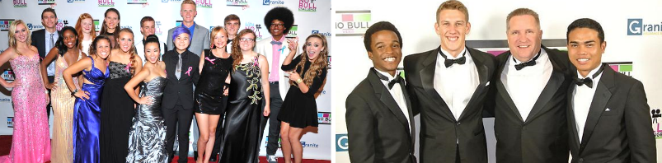
- Goal #4: Wristband Promotion
- Goal #5: Reach out to Region

Watch our award winning HUMANKIND. BE BOTH. video:
https://www.youtube.com/watch?v=ReqyQ9-MquM
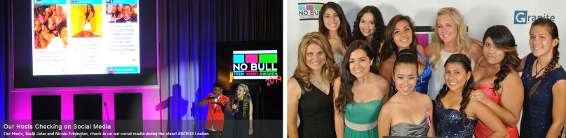
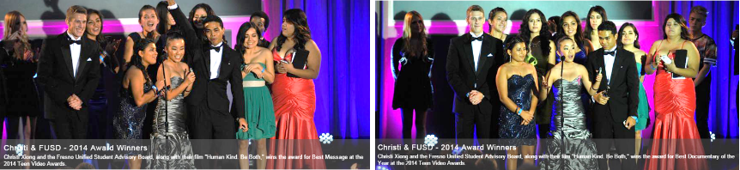

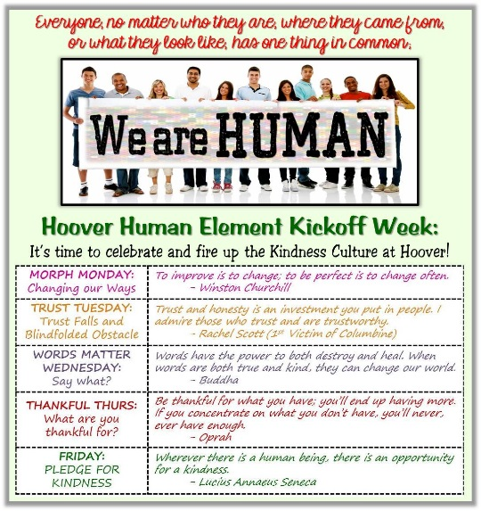
Lessons Learned:
- Time is needed to imbed as culture
- Outreach Down, Not Up (HS-MS-ES)
- Real student experiences
- Commitment from every site/leader
- Support that is seen and heard
- Ongoing training for student leaders
- Leader structure
- Resources (Financial, technical, human)
Watch our 2013-14 Recap Video here:
https://www.youtube.com/watch?v=1bQkwNmA5BQ
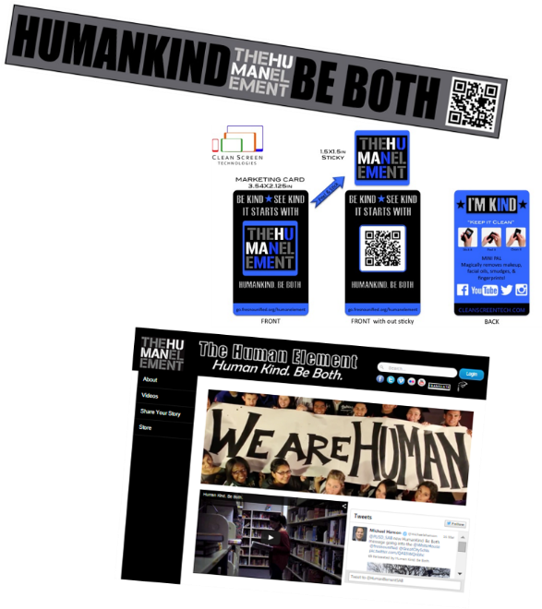
Keep Moving Forward:
- Assembly Package
- Adult Presentation
- Community Outreach
- Elementary Ambassadors
- NEW Promotional Materials
- Web Upgrade
- Human Element Store
- 2015-16 Videos/PSAs
- GoFundMe
Watch our Human Element PSA here:
https://www.youtube.com/watch?v=40yT6dg1wEY

Replicate It:
- Passionate Kids – Meeting Regularly
- Adult Coordination – Not Dictating
- Train your student leaders
- Creativity for your region/schools
- Develop a MANTRA
- Year 1: Adult Conversation/Board Support
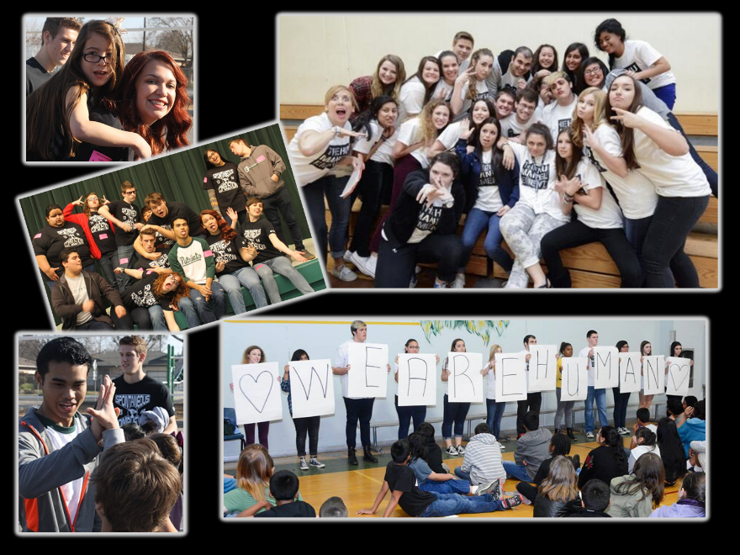
- Year 2: Students take the lead @ HS
- Year 3: Culture Building/Ongoing Support
- Year 4: Stay Relentless
- Year 5: Raise up others to lead

Stay Connected with FUSD SAB
and the Human Element:
go.fresnounified.org/humanelement
www.youtube.com/user/FUSDSAB
www.facebook.com/HumanElementFUSD
Twitter: @HumanElementSAB
www.gofundme.com/humankindbeboth

Watch our NSBA presentation slide show here:
http://youtu.be/rTk2-3N4j5g

