HUMANKIND. BE BOTH.
Fresno Unified School District – Student Advisory Board

How we got to the Human Element Campaign:
- The words ‘anti-bullying’ were not creating the change we wanted to see. We need to tell people what to do, instead of what not to do.
- Tired of hearing the slurs, hateful words, and observing hurtful actions.
- We wanted to make change – and we wanted our message to be positive and teach others.
- Kindness is a culture and we must show what that looks like on a daily basis.
- Vision: To protect and support each other through kindness as a culture
Watch our first slide show here:
https://www.youtube.com/watch?v=0-aW_l6dKLo
Watch our presentation to the Fresno Unified School Board here: https://www.youtube.com/watch?v=cFqk25kfgQs
Bracelets
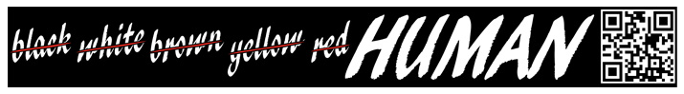
Program First Steps:
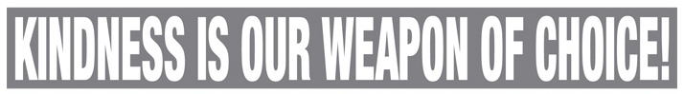
- Passionate Students
- Relevant topic…and made it POSITIVE
- Total creative control given to the students
- Adult Guidance, but no Hijacking!
- Created Partnerships with local business leaders and District leadership
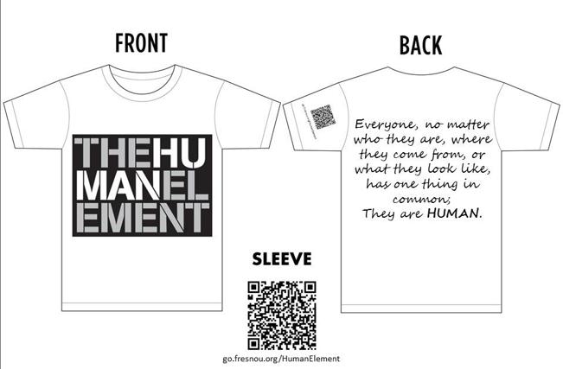
- Complete support from School Board
T-Shirts

Watch our first videos here:
https://www.youtube.com/watch?v=IBxQokFIcEA
https://www.youtube.com/watch?v=Fy2OIMJMlH4
https://www.youtube.com/watch?v=HD-_2iXEXak

Implementation 2013-14:
- Human Element Committees
- Student Training Day
- Goal #1: All High Schools will produce an all school assembly and HE Week
- Goal #2: 13-14 Human Element Video
- Goal #3: Field Test MS Assembly
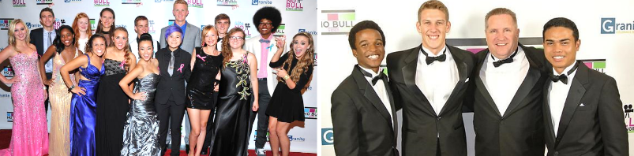
- Goal #4: Wristband Promotion
- Goal #5: Reach out to Region

Watch our award winning HUMANKIND. BE BOTH. video:
https://www.youtube.com/watch?v=ReqyQ9-MquM
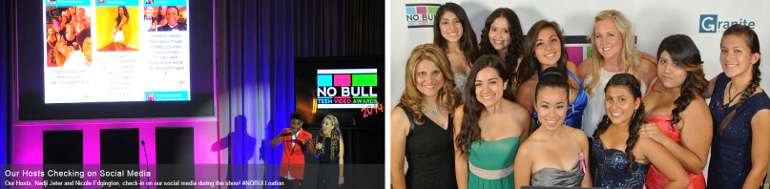
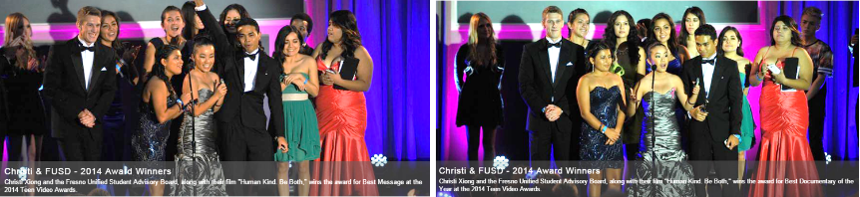

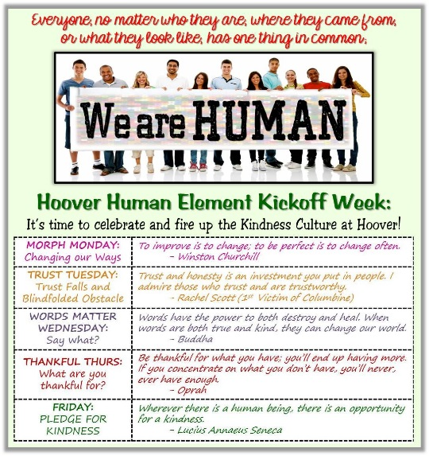
Lessons Learned:
- Time is needed to imbed as culture
- Outreach Down, Not Up (HS-MS-ES)
- Real student experiences
- Commitment from every site/leader
- Support that is seen and heard
- Ongoing training for student leaders
- Leader structure
- Resources (Financial, technical, human)
Watch our 2013-14 Recap Video here:
https://www.youtube.com/watch?v=1bQkwNmA5BQ
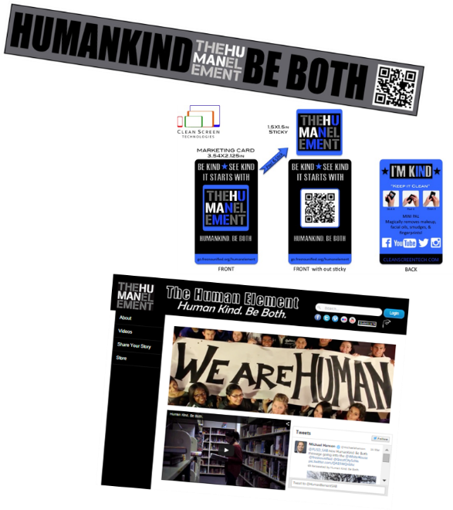
Keep Moving Forward:
- Assembly Package
- Adult Presentation
- Community Outreach
- Elementary Ambassadors
- NEW Promotional Materials
- Web Upgrade
- Human Element Store
- 2015-16 Videos/PSAs
- GoFundMe
Watch our Human Element PSA here:
https://www.youtube.com/watch?v=40yT6dg1wEY

Replicate It:
- Passionate Kids – Meeting Regularly
- Adult Coordination – Not Dictating
- Train your student leaders
- Creativity for your region/schools
- Develop a MANTRA
- Year 1: Adult Conversation/Board Support
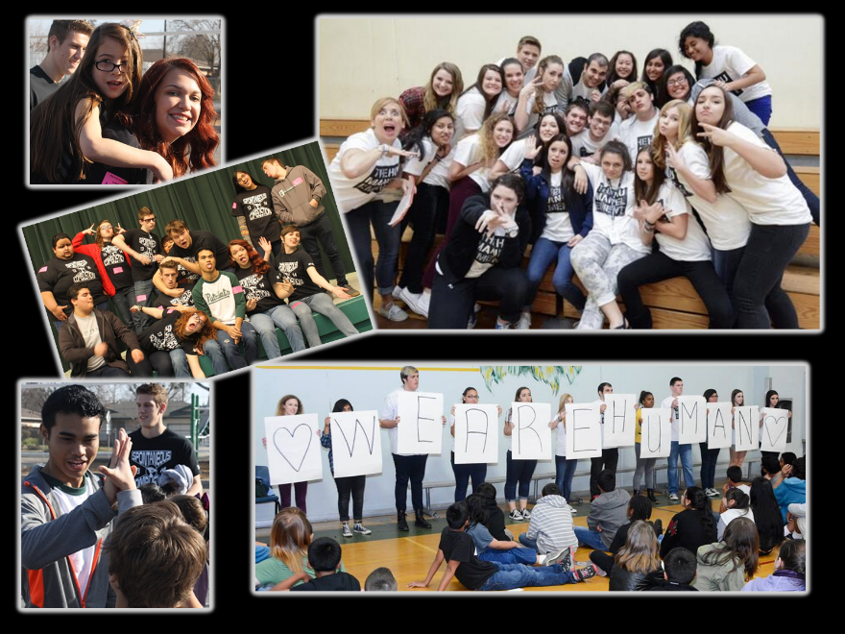
- Year 2: Students take the lead @ HS
- Year 3: Culture Building/Ongoing Support
- Year 4: Stay Relentless
- Year 5: Raise up others to lead

Stay Connected with FUSD SAB
and the Human Element:
go.fresnounified.org/humanelement
www.youtube.com/user/FUSDSAB
www.facebook.com/HumanElementFUSD
Twitter: @HumanElementSAB
www.gofundme.com/humankindbeboth

Watch our NSBA presentation slide show here:
http://youtu.be/rTk2-3N4j5g

